Journal homepage: http://www.journalijar.com INTERNATIONAL JOURNAL
OF ADVANCED RESEARCH

Research Article

Natural Rubber Biodegradation by Cladosporium fulvum and Enzymes responsible for Biodegradation
Nayanashree.G¹, Thippeswamy.B¹* and ²Krishnappa.M
- Dept. of P.G. Studies and Research in Microbiology, Bio-Science Complex, Jnanasahyadri, Kuvempu University, Shankaraghatta-577451, Shivamogga.(Dist.), Karnataka, INDIA
- Dept. of P.G. Studies and Research in Microbiology, Bio-Science Complex, Jnanasahyadri, Kuvempu University, Shankaraghatta-577451, Shivamogga.(Dist.), Karnataka, INDIA.
.
Manuscript Info Abstract

Manuscript History:

Received: 22 February 2014
Final Accepted: 24 March 2014
Published Online: April 2014

Key words:
Cladosporium fulvum, Hevea brasiliensis, vulcanization, polyisoprene, Laccase, Manganese peroxidase.
*Corresponding Author

Thippeswamy.B

Rubber products are widely used in our daily life these products are mainly made up of Natural rubber, which is obtained from the latex of tree Hevea brasiliensis. After usage of these products its disposal is the worldwide solid waste problem. One of the solution to this problem is microbial degradation of the product. During the present study rubber degrading microorganism were isolated. In the isolated organism Cladosporium fulvum effectively degraded the rubber sample.

Copy Right, IJAR, 2014,. All rights reserved

INTRODUCTION
Rubber products are widely used in our daily life these products are mainly made up of Natural rubber (NR) or cis-1,4 polyisoprene which is obtained from the latex of tree Hevea brasiliensis commonly called Rubber tree. Rubber tree grows throughout the world. Rubber trees are basically found in tropical & semitropical countries. Indonesia, Malaysia, Sri Lanka, South America and India (especially Kerala, Tamilnadu and Karnataka) have abundant resource of natural rubber. Two main types of polyisoprenoids that differ according to their isomerism are synthesized by plants; the first one is the cis isomer natural rubber (NR) [poly(cis-1,4-isoprene)] and the second one is the trans isomer gutta-percha (GP) [poly(trans-1,4-isoprene)]. The average composition of the natural rubber latex is 25-30% polyisoprene, 1-1.8% proteins, 1-2% carbohydrates, 0.4-1.1% neutral lipids, 0.5-0.6% polar lipids, 0.4-0.6 inorganic components, 0.4% aminoacids etc., and other 50-70% water. Dry weight of the natural rubber latex contains more than 90% of cis-1,4-polyisoprene and less than 10% of non-rubber constituents like proteins, carbohydrates, lipids etc (Rose et al., 2002).
The natural rubber latex is sticky and viscous in nature and very sensitive to temperature therefore it can not be directly used for the manufacturing of rubber products. For the manufacture of rubber products this latex should be subjected to vulcanization. During vulcanization some percent of elemental sulfur is added to rubber latex and it is heated to 140-180°C under pressure so that original sticky viscous material is converted a non-sticky and elastic material. During vulcanization the polyisoprene molecules are covalently linked by bridges of elemental sulfur which makes the rubber rigid elastic and resistant to temperature (Tsuchii et al., 2006).
The different rubber products are manufactured by using vulcanized natural rubber. During manufacturing along with vulcanized natural rubber other chemical additives will be added. The percentage of natural rubber content and the additives added mainly depends on the products manufactured.
The global rubber consumption is estimated to be 12.5 million metric tons in 2013 of which 65% were used for tire production and other 35% is used for the production of other rubber products such as rubber balloons, mats, rubber bands, pipes, gaskets, sheets etc.
After usage of these natural rubber products the disposal of these products are the world wide solid waste problem. One of the solution to reduce this problem is to recycle the used waste rubber. But due to the chemical cross linking formed during vulcanization it is not possible to simply melt and reshape the products as in case of polythene. So other alternatives such as microbial degradation of the product should be developed. Microbial degradation is mainly carried out by various microorganisms such as bacteria and fungi (Lions et al., 2000).
The present study was taken to isolate the natural rubber degrading fungi from the soil so that it can be used to degrade the rubber waste and to study the enzymes responsible for degradation

MATERIALS AND METHODS
For the isolation of fungi which were able to degrade natural rubber, the soil sample was collected from a local land fill of Shivamogga district and brought to the laboratory, along with this natural rubber latex and natural rubber sheet samples were collected from rubber processing unit and then it was brought to the laboratory and preserved in the refrigerator for further use.
Isolation of natural rubber degrading fungi
For the isolation of natural rubber degrading fungi soil burial method was followed. Natural rubber small discs were weighed and initial weight was recorded. Then, these discs were dumped in the soil and left for a period of six months of time interval. These natural rubber discs were removed regularly at time interval of two, four and six months respectively and weighed. For the isolation of natural rubber degrading fungi soil sample and natural rubber samples were plated on the potato dextrose agar media and kept for incubation at room temperature at 27±2ºC for 3 to 4 days for the isolation of fungi (Tsuchi et al., 1996). After incubation period, fungi were identified by staining and based on their microscopic and macroscopic appearance using standard manuals (Ellis, 1971 and 1976; Pitt, 1979; Domsch et al., 1980 ;Subramanian, 1983; Ellis, 1997; Gilman, 2001; Nagamani et al., 2006).
Plate assay for the screening of fungi capable of degrading natural rubber

For the screening of natural rubber degrading fungi pure culture isolates were directly inoculated on the sterilized, pre weighed natural rubber discs and then kept for incubation for 2 months. After a time interval of 2 months natural rubber sample inoculated with organisms were washed thoroughly, dried at 50°C in hot air oven for 24 hours and final weight was recorded (Borel et al.,1981).
Screening of natural rubber degradation by using Mineral salt medium (MSM)
Natural rubber degrading ability of the fungi was checked in the laboratory conditions by growth experiment in mineral salt medium (MSM) (Pan et al., 2009), where natural rubber was used as sole carbon source. Previously isolated fungi were inoculated to different conical flasks containing MSM and kept for incubation for 2 months on rotary shaker. Fungi were incubated at 27±2°C, triplicates were maintained. After incubation period natural rubber discs were removed and observed for the growth of fungi. Then natural rubber discs were washed dried at 50°C in hot air oven for 24 hours and weight loss was checked (Tsuchii and Tokiwa, 2001).

Confirmation of natural rubber degradation by staining with Schiff’s reagent
Evidence for degradation and mineralization of cis-1,4-polyisoprene rubber hydrocarbon chain was obtained by staining treated natural rubber discs with Schiff’s reagent. In a tightly stopper bottle, 10 ml of fuchsin reagent was added to a sample and kept for incubation for 10-30 minutes at room temperature. After 10-30 minutes excess amount of the reagent was discarded and 10ml of the sulfite solution was added in order to suppress nonspecific reaction of untreated sample (Berekka et al., 2000).
Confirmation of natural rubber degradation by Scanning Electron Microscopy (SEM)

Evidence for degradation and mineralization of cis-1, 4-polyisoprene natural rubber hydrocarbon chain was obtained by observing the natural rubber discs under SEM. For the observation natural rubber discs buried in the soil and present in the MSM, which were subjected for degradation were observed under field emission-scanning electron microscopy (FEI-SIRION, Eindhoven, Netherland) (Lions et al., 2000).
Confirmation of natural rubber degradation by Fourier Transform Infrared Spectroscopy (FTIR)

Chemical changes that arose directly on the natural rubber surface as result of the degradation process were determined using FTIR spectroscopy. NICOLET 380 FTIR spectrophotometer from Thermo Fisher Scientific, France was used which gives transmittance spectra in IR range 4000 to 400 nm. (Roy et al., 2005).
Characterization of enzymes responsible for biodegradation of natural rubber

It was studied that laccase and manganese peroxidase enzymes were responsible for the natural rubber degradation.

Screening for Laccase and Manganese peroxidase enzyme production by Cladosporium fulvum

Screening for laccase enzyme produced by Cladosporium fulvum was done on plates containing following composition (g/l): 3.0 peptone, 10.0 glucose, 0.6 KH₂PO₄, 0.001 ZnSO₄, 0.4 K₂HPO_{4,} 0.0005 FeSO₄, 0.05 MnSO₄, 0.5 MgSO₄, 20.0 Agar (pH-6) supplemented with 0.02% guaiacol. Cladosporium fulvum was inoculated into this plate and the plate was incubated at 30°C for 7 days. Laccase activity was visualized on plates containing 0.02% guaiacol, since laccase catalyzes the oxidative polymerization of guaiacol to form reddish brown zones in the medium (Viswanath et al., 2008).
For the screening of manganese peroxidase enzyme producing organisms H₂O₂ was added to the laccase screening media.
Mass production of enzyme by submerged fermentation

Pure cultures of Cladosporium fulvum was inoculated to submerged state fermentation medium for the production of extracellular enzymes by using MSM media and was maintained at the incubation temperature of 27±2ºC for 3 months (Shraddha et al., 2011).
Determination of Laccase and Manganese peroxidase enzyme activity by using Spectrophotometer

Guaiacol (2mM) in sodium acetate buffer (10mM pH 5.0) was used as substrate. The reaction mixture contained 3ml 10mM acetate buffer of pH 5, 1ml guaiacol and 1ml enzyme source and enzyme blank contained 1ml of distilled water instead of enzyme source. The mixture was incubated at 30ºC for 15minutes and absorbance was read at 450nm blank using UV spectrophotometer (Papinutti et al., 2006). Manganese peroxidase enzyme activity was calculated by following laccase enzyme activity determination procedure, but for the reaction mixture 1 ml of H₂O₂ was added and incubated.
Protein estimation
Protein concentration was estimated to determine specific activity of enzyme. The protein concentration was determined by the Lowry’s method, as described by Lowry’s (1951) using Bovine Serum Albumin (BSA) as a standard, absorbance was read at 660 nm using JENWAY- 6305 UV-VIS Spectrophotometer.
Testing of Natural Rubber degrading ability of enzymes
Degrading ability of the enzyme which were purified was tested by adding enzymes to the flasks containing acetate buffer and previously weighed natural rubber sheets and kept for incubation on rotary shaker for a period of 15 days at room temperature. After incubation period rubber discs were weighed to check weight loss and subjected for staining to confirm natural rubber degradation (Fujisawa et al., 2001).

RESULTS
Isolation of natural rubber degrading fungi
Rubber samples and the soil sample of 2, 4 and 6 months were plated on the potato dextrose agar medium, different 14 fungi were isolated and recorded. In the isolated organism Cladosporium fulvum was pre-dominant and commonly isolated. Thus it was screened to test natural rubber degrading ability. Weight loss was also observed in all the rubber samples which was removed at different time interval (Table 1).
Table -1. Weight loss of rubber by soil burial method
Sl.No. | Number of months | Initial weight ( g) | Final Weight ( g) | Weight loss (g) | Weight loss In (%)
1. | 2 | 3 | 2.84 | 0.16±0.01 | 5.3
2. | 4 | 3 | 2.63 | 0.37±0.04 | 12.3
3. | 6 | 3 | 2.12 | 0.88±0.01 | 29.3
Result are expressed in standard error where n=3.

Plate assay for the screening of microorganisms capable of degrading natural rubber

In Cladosporium fulvum inoculated natural rubber discs initial weight was 10g and final weight was 8.46g and there was a decrease in 1.54 ± 0.001g of weight and percentage of weight loss was 15.4%.
Screening of natural rubber degradation by using Mineral salt medium (MSM)
Growth experiment was conducted by using mineral salt medium weight loss was observed and growth of fungi was observed on the rubber discs. Initial weight of the Cladosporium fulvum inoculated rubber strip was 2g and the final weight was 1.34g and there was a weight loss of 0.66±0.002g and percentage of weight loss was 33%.
Confirmation of rubber degradation by staining with schiff’s reagent
Rubber sheets which were inoculated with microorganism turned to purple colour and there was no colour formation in the control. Formation of purple colour in the treated sample is due to the presence of aldehyde and ketone group which is produced as a result of degradation of cis-1,4-polyisoprene units.
Confirmation of natural rubber degradation by Scanning Electron Microscopy (SEM)

Natural rubber discs were observed under SEM, bio-film formation, complete disintegration and formation of cavities on the natural rubber discs was observed (Fig. 1).
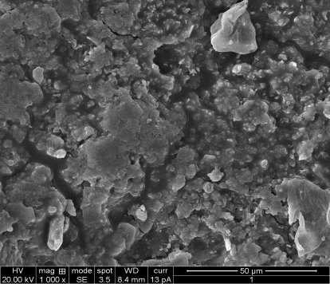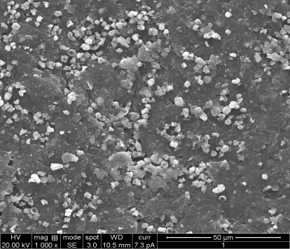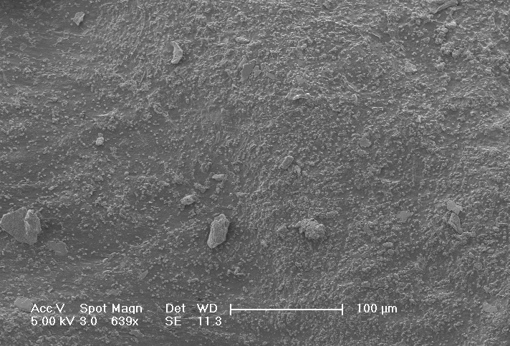
Rubber discs buried in soil Cladosporium fulvum treated Control
Fig. 1. SEM images of natural rubber showing degradation
Confirmation of natural rubber degradation by Fourier Transform Infrared Spectroscopy (FTIR)

Natural rubber discs, which were treated by Cladosporium fulvum were subjected for FTIR studies peaks were observed at the wave length between 2725.89 cm⁻¹ and 1662.34 cm⁻¹ having H–C=O:C–H stretch and C=O stretch which indicates the presence of aldehydes and ketones, released as a result of natural rubber degradation in the treated sample. Presence of these aldehyde and ketone group confirms natural rubber degradation. Peaks showing the presence of aldehyde and ketone are absent in control (Fig. 2).
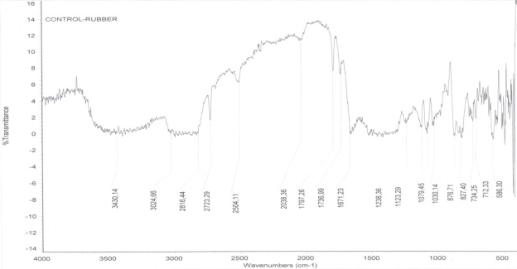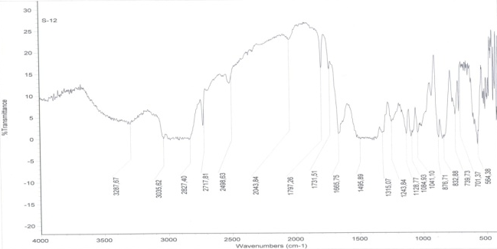
Rubber control Cladosporium fulvum treated
Fig. 2. Confirmation of natural rubber degradation by FTIR
Enzymatic studies of rubber degradation
It was studied that laccase and manganese peroxidase enzymes were responsible for the rubber degradation.
Screening for Laccase and Manganese peroxidase enzyme production by Cladosporium fulvum

Cladosporium fulvum was inoculated on the laccase and manganese peroxidase medium there was a formation of reddish brown colour around the colonies since laccase and manganese peroxidase catalyzes the oxidative polymerization of guaiacol to form reddish brown zone. Cladosporium fulvum which showed positive result for rubber degradation showed positive result for laccase and manganese peroxidase enzyme screening.
Determination of Laccase and Manganese peroxidase enzyme activity by using Spectrophotometer

Cladosporium fulvum, showed more manganese peroxidase activity compared to laccase activity. Both laccase and manganese peroxidase enzyme activity was maximum in 10th week. Laccase enzyme activity in 10th week was 0.0184 IU and manganese peroxidase activity in 10th week was 0.0197 IU.
Table 2. Showing laccase and manganese peroxidase activity
Cladosporium fulvum | 1st week | 2nd week | 3rd  week | 4th  week | 5th  week | 6th  week | 7th  Week | 8th week | 9th week | 10th week | 11th week | 12th week
Laccase | 0 | 0 | 0.0013 | 0.0022 | 0.0041 | 0.0064 | 0.0078 | 0.0091 | 0.0104 | 0.0121 | 0.0112 | 0.0101
Mangenese peroxidase | 0 | 0 | 0.0015 | 0.0028 | 0.0045 | 0.0069 | 0.0089 | 0.0106 | 0.0112 | 0.0135 | 0.0116 | 0.0098

Fig. 3. Laccase and Manganese peroxidase enzyme activity in IU
Testing of Rubber degrading ability of enzymes
After incubation time weight loss were observed in rubber pieces and formation of pink colour was also observed when treated rubber pieces were subjected to schiffs staining.
After incubation time when weight was checked there was decrease in 0.4 g of weight in laccase enzyme inoculated sample and 0.5g weight loss in manganese peroxidase inoculated sample.

DISCUSSION
Present study was carried out to isolate natural rubber degrading fungi. It was studied that Cladosporium fulvum is capable of degrading natural rubber. Degradation of natural rubber was studied by carrying out growth experiment in MSM, and degradation was confirmed by staining, SEM, FTIR studies. Further enzyme responsible for degradation was studied. Laccase and manganese peroxidase were the enzymes responsible for degradation.
Similar attempts were made by several other scientists to degrade rubber by using microorganisms.
Roy et al.,(2005) made an attempt to study on natural rubber (NR) biodegradation through solid-state fermentation (SSF) and submerged fermentation (SMF) has been carried out for both bacterial as well as fungal species. There was a change in the organic carbon content along with the average molecular weight of the treated rubber samples indicated rubber hydrocarbon utilization and its degradation.
Berekaa et al., (2000) conducted similar work and tested the biodegrading ability of different bacteria belonging to the genera Gordonia (strains Kb2, Kd2 and VH2), Mycobacterium, Micromonospora and Pseudomonas. All strains were able to use natural rubber (NR) as well as NR latex gloves as sole carbon source.
Similar study was carried out by Tokiwa et al., (1999) in his study he showed that forty-seven percent of a tire tread strip with a natural rubber content of 100 phr (parts per hundred of rubber) was completely mineralized by a mutant strain, Rc, of the rubber-degrading organism, Nocardia sp. Strain 835A.

CONCLUSION
Rubber products are widely used in our daily life. These products are made up of natural vulcanized rubber and other chemical additives. Due to vulcanization of the natural rubber these rubber are very resistant to high temperature and persist in environment for very long time. Rubber materials have been increasingly used now a days in different area after usage its disposal is a very big solid waste problem. It can not be easily recycled due to the sulphur cross linking formed during vulcanization. If they are burnt they release enormous amount of carbon-di-oxide and some other gases which cause environmental pollution and contribute to the global warming. Rubber products such as balloon which are disposed in the natural environment are considered to be dangerous to wild animals if they are consumed by animals.
So, one of the alternative way to solve these problems is to subject these product to biodegradation. During the present study rubber discs were dumped in the soil were removed at regular interval of time and then plated on the media to isolate the organism. In the isolated organism and effectively degraded the rubber sample. The present study has showed that, it is possible to use Cladosporium fulvum to degrade natural rubber effectively. Along with this, enzymes responsible for natural rubber degradation were also characterized.

REFERENCE

Berekaa, M.M., Lions, A., Reichelt, R., Keller, U. and Steinbuchel, A. (2000). Effect of pretreatment of rubber material on its Biodegradability by various rubber degrading Bacteria, FEMS Microbiology Letters, 184: 199-206.

Borel, M., Kergomard, A., and Renard, F. (1981). Degradation of Natural rubber by fungi imperfecti, Agricultural Biology and Chemistry, 46: 877-881.

Domsch, K.H., Gams, W. and Anderson, T.H. (1980). Compendium of soil fungi. Vol 1. Academic Press Inc. New York: 1-859.

Ellis, M.B.(1971). Dematiaceous hyphomycetes. Kew: Common wealth mycological institute. England: 1-608.

Ellis, M.B. (1976). More Dematiaceous hyphomycetes. Kew:Common wealth mycological institute. England: 1-507.

Ellis, M.B. and Ellis, J.P. (1997). Microfungi on Land plants: An Identification Handbook. Richmond Publishers, London: Croom Helm: 868.

Gilman, J.C. (2001). A manual of soil fungi. 2nd edition. Biotechnology Books. New Delhi: 1-392.

Lions, A., Rudolf Reichelt, R., Keller, U. and Steinbuchel, A . (2000). A Gram negative bacterium identified as Pseudomonas aeruginosa, AL98, is a potent degrader of natural rubber and synthetic cis-1,4-polyisoprene, FEMS Microbiology Letters, 182: 155-161.

Lowry, O.H., Rosebrough, N.J., Farr, A.L., and Randall, R.J., (1951). Protein measurement with the folin phenol reagent, Journal of general Microbiology, 31:3017-3027.

Nagamani, A., Kunwar, I.K. and Manoharachary, C. (2006) Handbook of Soil Fungi. I. K. International Pvt. Ltd. New Delhi. 1-477.

Pan, L., Gung, G.J., Yin, B. and Cheng, P.S. (2009). Contribution to deterioration of polymeric materials by slow growing Bacteria Nocardia corynebacterioides, International Biodegradation and Biodeterioration, 63: 24-29.

Papinutti, L., and Martinez, J. M., (2006). Production and Characterization of Laccase and Manganese peroxidase from the ligninolytic fungus Fomes sclerodermeus, Journal of technology and biotechnology, 81:1064-1070.

Pitt, J.I. (1979). The genus Penicillium and its teleomorphic states Eupencillium and Talaromyces. Academic Press Inc, Ltd. London:1-634.

Roy, V.R., Das, M., Banrjee, R. and Bhowmick, A. (2005). Comparative studies on rubber biodegradation through Solid state and Submerged fermentation, Process Biochemistry, 42: 181-186.

Shraddha, Shekher, R., Sehgal, S., Kamtania, M., and Kumar, A., (2011). Laccase microbial source Production, Purification, Potential biotechnological application, Enzyme Research, 1-11.

Subramanian, C.V. (1983). Hyphomycetes, taxonomy and biology. London. New York: Academic Press: 410-461.

Viswanath, B., Chandra, M. S., Pallavi, H., Reddy, (2008). Screening and Assessment of Laccase Producing Fungi isolated from different environmental samples, African Journal of Biotechnology, 7:1129-1133.

Tsuchii, A. and Tokiwa, Y. (1999). Colonization and disintegration of Tire Rubber by a colonial Mutant of Nocardia, Journal of Bioscience and Bioengineering, 87: 542-544.

Tsuchii, A. and Tokiwa, Y. (2001). Microbial degradation of Tire rubber particles, Biotechnology Letters, 23: 963-969.

Tsuchii, A., Takeda, K., Suzuki, T. and Tokiwa, Y. (1996). Colonization and degradation of rubber pieces by Nocardia species, Biodegradation Journal, 7: 41-48.

