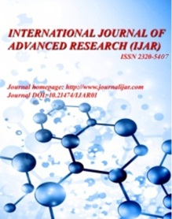
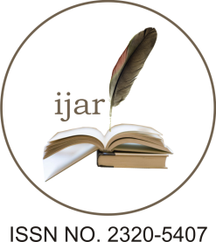
Journal Homepage: - www.journalijar.com

Article DOI: 10.21474/IJAR01/xxx
DOI URL: http://dx.doi.org/10.21474/IJAR01/xxx

Research Article

SOLID WASTE MANAGEMENT IN TAMIL NADU.

*V. Nathiya¹ and Dr. V. Thandapani².
- Research Scholar, Department of Economics, Thiru.Vi.Ka.Govt. Arts College, Tiruvarur.
- Assistant Professor, DEPARTMENT OF ECONOMICS, PRESIDENCY COLLEGE, CHENNAI.
……………………………………………………………………………………………………....
Manuscript Info Abstract
……………………. ………………………………………………………………

Manuscript History
Received: xxxxxxxxxxxxxxxx
Final Accepted: xxxxxxxxxxxx
Published: xxxxxxxxxxxxxxxx

Key words:-
0000000000000.
Corresponding Author:- 000000.
Address:- 0000000.

The nearby study analyses the solid waste management in Tamil Nadu. Solid waste comprised all the wastes arising from human and animal activities that are normally solid and that are discarded useless or unwanted. The increasing difficulty in managing wastes in different states in Tamil Nadu. On the basis of the results, it was recommended to increase public awareness through enlightenment campaign against danger of indiscriminate dumping of wastes as they affect human health.

Copy Right, IJAR, 2019,. All rights reserved.

……………………………………………………………………………………………………....

Introduction:-

