
Journal homepage: http://www.journalijar.com INTERNATIONAL JOURNAL
OF ADVANCED RESEARCH

Research Article

MATERIAL, COLOR AND TEXTURE ANALYSIS ON FACADE ARCHITECTURES OF HOTELS and Evaluation Of Facades Of Afyon Hotels Within This Context

S. Ebru OKUYUCU, Mehmet SARIKAHYA

Manuscript Info Abstract

Manuscript History:

Received: 15 June 2015
Final Accepted: 23 July 2015
Published Online: August 2015

Key words:

*Corresponding Author

S. Ebru OKUYUCU

Architectural structures which became the prestige and image of a country and city have also become social, cultural and aesthetic indicator of that nation as well. Particularly, tourism structures which are sources for domestic and foreign users display an increasing graphic in terms of architectural design. Within this context, besides functionality, aesthetic, charm and facade orders have also taken an important place among the architectural design criteria of the hotels today. As far as the indoor designs of the hotels, outdoor designs also strive to create a positive perception over the users. To this end, External facade has been taken as the architectural element which establishes the most direct relation with hotels which constitute urban identity and with physical environment users.
Copy Right, IJAR, 2015,. All rights reserved

INTRODUCTION
In architecture, effects of shape, color, texture and material over the people and life are important inevitably. Shaping and fiction of the architectural facades which form the city have important responsibility for affecting the physical users. Particularly, the external facades of the hotels which create the image of the city have an important place in terms of visual richness, aesthetic and message transmission. The purpose of the study is to evaluate the shaping of color, material and texture factors which form the facade designs of the hotels and shaping of elements which form the design order in terms of the users thus to measure how much these criteria have been fulfilled in the external architectures of the hotels in Afyon and to query the place of the facade fiction in design. Within the scope of this study; taking off the design criteria of hotel exterior architects within a general framework, based on the assertion that; color, shaping of facade elements and texture factors are the most emphasizing factors in exterior facades, the exterior facade architecture of the five hotels selected in Afyon has been analyzed. The reason for the selection of these hotels is; the features of the exterior facade architecture of all of these hotels are different from each other in terms of materials used, shaping, color, texture and fiction, and the perception of the user may be evaluated in different scales within this context. The procedure used in the study is that; an approach has been developed in which the individuals’ wish, admiration and preferences are queried by questionnaires, for the purpose of making basis for new designs by determining visual appreciation and satisfaction data along with color, material and texture factors and by revealing the characteristics and stylistic features of the facades. In the study, for subjective evaluation, 5 likert scale, sorting and closed end- questions were asked. On the other hand, statistical evaluation has been made by using regressions, graphics and correlations in SPSS program. In the questionnaire, there exist 23 questions which have been prepared in terms of the analysis of the shaping of color, material, texture and facade elements in hotel exterior facade architects and this survey has been applied to 254 attendants comprising from the academics and students of the Faculty of Fine Arts. Therefore, the study performed and the model created are thought to provide contribution to the design and evaluation process of the hotel facades.

Material, Color And Texture In The Exterior Facades Of The Hotels
As tourism has become a global event today, the necessity of tourism structures has increased considerably. In line with the increasing graphic of vacationing which takes its place in people’s social lives, architectural fictions of tourism structures have become more functional, aesthetical and flashy.
Hotels are the facilities which serve for the customers’ need of accommodation basically and which may also involve auxiliary and complementary facilities for food- drink, sport and entrainment needs. (Yolcu, 2006). In the hotels which are designed according to various claims and necessities, there are some criteria for the formation of place and identity. These criteria create an integrity with environment, user, its activity, wish and values and perception (Ertürk, 1984). Obligation of the fulfillment of the users’ physical, social and psychological needs becomes one of the most important determinant factor for the arrangement of hotel place (Alp, 1993).The relation between the place and human is established through perception. The perception of the place is directly related to the features of that place and the structural properties (wall, flooring, roof), physical properties (color, texture, dimension) and fictional properties (place’s forming a composition alongside) of the place in designing come into prominence accordingly (Önder, 1995).There are various architectural elements which form the hotel design
Mass design
Place organization
Dimensional properties
Facade Order (Çakırkaya, 1994).
The exterior facade architecture of the hotels which are the source of prestige for cities are designed to complete the urban image and to form positive perceptions over the customers. Within this context, in line with rapidly developing technology, new trends and new expectations, hotels’ exterior facade design inputs have diversified. Facade order is related to the image served to the user by the hotel. Facade is the primary element perceived by the building’s user. By the face order, to it is available to transmit messages to the user, to attribute a meaning to the hotel and to excite various feelings. Facade order is closely related with the mass. Facade order is formed by the usage of the following factors
Material used in the facade
Shaping of facade elements
Color preference
Motions in third dimension ( retractions and consoles )
Light (Çakırkaya, 1994).
The facade order of the hotels which are included in the design criteria of the hotel in line with the purpose of the study shall be analyzed in terms of materials used in facade, shaping of facade elements and color and texture.

Material in Hotel Facade Architecture

Material used in structures are among the factors which take place within the scope of design and form the shaping of that design during the formation and usage process and which affect the comfort of the user. One of the most important points in structure designing is that the materials are being used under the awareness of their properties. The material used for the external surfaces of the structures brings the differences into the forefront and provides contribution to the structure to acquire an identity. Particularly in hotel architectural fictions which have become to be prestige structures for the city, identity is sought for both interior and exterior facade designs. Within this context, material used in hotel exterior facade surfaces and the meaning and feeling introduced to the user by that material have become significant considerably. Within the perception process, the variety of the visual stimulus which is almost infinite is decreased according to the degree of its importance for the observers and converted into a personal image according to the individual’s own accumulation. Architect may utilize the advantage of this conversion in his design. For instance, by using a small brick shapes at hotel facade, as a result of subconscious assumptions regarding the scale, he may introduce a richer image to a building. (Jones and Lederman, 2006).
Stone, as a magnificent basic material of the history, besides its values added by its processing style, is always a qualified material. It has a powerful touching richness when used in hotel facades, either in the manner of massive stone or masonry, or as a covering material. It gives a reliability feeling to the one who follows it or accommodates therein. With glass surfaces which are a typical material for today’s hotel exterior facade architecture; a flowing image from the frame, maximum usage and light opportunity have been introduced. On the other hand, the architectural mass has shaped into a shell with transparent and variable characteristic due to the glass. (Cimcoz, 2001) Such that; famous Architect Frank Lloyd Wright considers glass surfaces as the materialization of the light (Wright, 1953). Wright, considers the glass as the most paradoxical material within the architectural history and the most complicated material in terms of its relation with the nature. Despite being a solid and shining plane, glass provides an excellent view shed at hotel exterior facades and is able to open the structure with landscape, capable of reflecting every changing view of the light and each breath of the wind. Another system used for hotels’ exterior facades is the curtain walls. Glass facades; arisen in parallel with the improvements occurred in material and construction technology as of early 20th century, has become an inevitable construction shell for the hotels due to their lightness, aesthetic images, easier manufacture and assembly feature and their resistance against climate in a short time.(Çetiner, 2002).
Within this context, in order to measure the users’ perception of hotel exterior facade architects, factors such as the specification of the material used at facade, its function and the aesthetic provided by should be evaluated.

Shaping Of Elements Used In Hotel Facade Architecture

The concept of shape expresses its stylistic order formed by the permanency of the limits which define the general outlines of an object. The concept of shape in architecture, alike, is the holistic and general order owned by the mass or the space. It is possible to mention about the shapes of parts or elements, as the shape of mass or place may be mentioned. Such as ; shape of facade, shape of roof, shape of bay window (Onat, 1995)
There are various definitions of the concept of facade. In Architectural vocabulary, the word ; “ facade” is defined as;” each of appearing surfaces of an building, particularly the front surface or the view seen from infinite, perpendicular direction to the building’s face.” (Hasol,1990) and this word has passed from Arabic into our language. The facade which means the exterior face of the building involves the entrance which is generally the main face of the building, and the structure is characterized by being detailed by facade elements such as window, door, balcony as well as by decorations. Krier states; “ if a face of a building, in other words a facade is being mentioned, it means that the front face of the building towards the street is being expressed.”(Aydınlı, 1993). Hotels, on the other hand; are given a meaning by the urban users by forming a stylistic composition upon the features of exterior architecture and form the image of a city with the meanings they bear. Shaping of elements such as window, door, balcony, door frame, arch which form the exterior facade of the hotels emphasize the visual effect of the hotels due to the fiction and order they formed. Within this context, the perception of elements of hotel facade architecture over the user should be evaluated.

Color And Texture In Hotel Facade Architecture

Designers are required to affect the user’s psychology for the place consciously, to be aware of physical properties such as color, shape, measure- rate which form the place’s fiction and other factors such as heat, light, voice and odor and to be capable of comprehending the psychological impacts of these factors over the user. There exists a relation between color and shape in urban places. It is impossible to think about the color without a shape and to perceive it alone. Shape and colors condition each other mutually. Some colors; when combined with specific shapes, their values get stronger; however with combination of others, their values decrease (Aktürk, 1999).
Color: Color which is perceived visually and not considered separate from the light introduces a character and qualification to the place where it is used. Different psychological impacts which are formed by different types of colors vary from person to person, however the surveys and experiments conducted provides an opportunity for the formation of the generalization relevant with colors. Harmonized colors’ holistic feature create an unity in the place, and an order which consists of different colors provided diversity in the place. Opposite colors arises a feeling of wideness in case used in horizontally and arises a feeling of height in case used vertically. (Gürpınar,2000). Hot, bright and dark colored elements are perceived bigger and closer as they are and arise the feeling of weight, on the other hand, cold, light and dull colored elements are perceived smaller and further then they are and arise the feeling of lightness. (Rasmussen,1994). Within this context, color perceptions on hotel facades may be evaluated as follows:
Instead of arising the feeling of fullness or emptiness on the facade, by using contrast colors with each other, an architecture which is perceived as different color surfaces may be created.
Facade integrity may be scattered by using geometrical color surfaces.
The light or dim position of the facade may be provided by bright or dull colors.
In case used correct, color may have the feature of expressing the character of a building and the feeling which is requested to be arisen in an observer.
The nature of the facade may be increased by forming a color composition.
Facade elements which are not found aesthetic in architecture may be masked by selection of harmonized colors.
Facade elements which are requested to be emphasized in architect may be expressed by selection of harmonized colors.
Texture: Appearances of the shapes which form the place depend on the features of the texture. Texture is a property exists in the material’s own formation. For the occurrence of the texture, rough surface– appropriate light, textural deepness (cove- flange) are required, and the change in colors provide a visual character accordingly (Aydınlı, 1989). Designer’s awareness of the impacts of the textures to be selected in the place over the human is useful in terms of psychological impacts requested to be created in the place. The tools used there in , with their textures, reveal different perceptions by the human. Texture may create psychological effects such as; softness- hardness, heaviness- lightness, silence- noise, peace- anxiety, stillness-dynamism, silence-excitableness, slackness-gloom.
Soft textures surfaces on the exterior facades of the hotels are defined as; silence, convenience, monotony; whereas surfaces with cold, weak and hard textured surfaces are defined as; dynamic, stimulatory, attracting, powerful and hotter, exiting. Besides, flat textured surfaces on the facades of the hotel leave a colder impression compared to rough surfaces (Küller, 1973).

Field Study

“Facade is the face of the building, it carries the expression of integrity. A building without a facade is not a building without a face completely however it is a building without an expression as it does not involve the life therein..”
Scruton, 1979, (Özdemir, Başkaya,2005)
It is possible to mention that facades are the part of an architectural product which become the target of judgment mostly. In this case, facades, that’s to say are an important component of exterior shell architectural aesthetics (Ustaömeroğlu, 2001). In this study, the contribution of the factors of shaping of color, material, texture and facade elements- which form the hotels’ exterior facade architecture- over hotel facade fiction has been measured. With this experimental study; the aesthetical evaluation of hotel buildings, having different shapes in relation with the usage of facade fiction; facade elements, material, color and texture, gains importance. A questionnaire prepared from this point of view was directed to students and academics of the Faculty of Fine Arts and they were requested to answer some questions. Within this context; stylistic analysis of the facades of five different hotels located in Afyon were made and based on the data found, contextual features of the facade analysis of the hotel buildings were determined and relevant proposals were brought forward accordingly. Proposal model prepared by Şenyiğit and Altan(2011) was taken basis .(Table 1.)
Table.1 Model proposed for the subjective and stylistic evaluation of Afyon Hotel facades (Source:Okuyucu)

According to the results of the questionnaire, data obtained from demographic questions are evaluated as given below: (Table. 2).

Table. 2. Demographic data obtained from questionnaires (Source:Authors)

Gender | (%) | Age distribution | (%) | Education Status | (%)
MAN | 48.8 | 18-28 | 91.3 | PRIMARY –SECONDARY
WOMAN | 51.2 | 29-39 | 5.1 | HIGH SCHOOL | 70
 |  | 40-60 | 3.5 | ASSOCİATE DEGREE | 9.4
 |  |  |  | BACHELOR’S DEGREE | 12.2
 |  |  |  | POSTGRADUATE | 8.4

Questions in the questionnaire involve the factors such as the shaping of color, texture, material and facade elements of the hotel facades. The factors of shaping of color, material, texture and facade elements used in hotel architecture were analyzed under the consideration of data obtained .
Data obtained from the questions of the survey made for the analysis of the materials used for hotels’ exterior facade architecture are in the manner given below: (Table 3.)

Table 3. Evaluation of materials on the exterior facade architecture of the hotels. (Source:Authors)

 | A | B | C | D | E
Positive | 75,2 | 21,3 | 36,2 | 29,9 | 38,5
Negative | 20 | 56,7 | 44,1 | 19,7 | 25,6

A. Exterior facade materials are luxury
B. Exterior facade is covered with marble
C. Exterior facade is covered by stone material
D. Exterior facade is cladding type
E. Exterior material is covered by mixed materials

Data obtained from the questions of the survey made for the analysis of color used on hotels ‘exterior facade architecture are given below : (Table 4.)

Table 4. Evaluation of utilization of color on the exterior facade architecture of the hotels(Source:Authors)

 | A | B | C
Positive | 59 | 34,3 | 19,3
Negative | 30,4 | 51,6 | 67,3

A. Exterior facade consists of various colors
B. Exterior facade involves single color
C. No colors were used on exterior facades

Data obtained from the questions of the survey made for the analysis of the texture of exterior facade of the hotels are given below : (Table 5.)

Table 5. Evaluation of the texture of the exterior facade architecture of the hotels (Source:Authors)

 | A | B | C | D | E | F | G
Positive | 57,1 | 61,4 | 70,4 | 30,3 | 79,1 | 69,3 | 83,5
Negative | 28,8 | 22,2 | 19,3 | 56,3 | 11 | 12,5 | 11

A. Exterior facade is traditional
B. Exterior facade is in the form of Seljuk or Ottoman style
C. Exterior facade is in the manner of modern style
D. Excessive decoration on the exterior facade
E. Exterior facade is charming
F. Facade involves geometrical shape
G. Exterior facade increase the prestige.

Data obtained from the questions of the survey made for the analysis of the shaping of exterior facade elements in hotels’ exterior facade architecture areas the following: (Table 6.).

Table 6. Evaluation of shaping of exterior facade elements in hotels’ exterior facade architecture (Source:Authors)

 | A | B | C | D | E | F | G
Positive | 51,6 | 59,1 | 44,1 | 37,4 | 68,9 | 59,8 | 68,5
Negative | 20,4 | 19,6 | 33,4 | 39,4 | 18,1 | 16,1 | 18,1

A. Doors and windows are arched
B. Lobby can be seen from outside
C. Doors and windows are made of wood
D. Doors and windows are made of PVC
E. Doors and windows are charming
F. Entrance door is located in the middle of the front facade
G. Balcony exists on exterior facade

These data obtained shall shed light on the evaluation of existing stylistic features of exterior facade architects and the analysis of design fiction of Korel Hotel, İkbal Hotel, Oruçoğlu Hotel, Anemon Hotel Güral Hotel, each located in Afyon. ( See Figure 1, Figure 2., Figure 3., Figure 4., Figure 5.).

Name of the Hotel |  | HOTEL KOREL
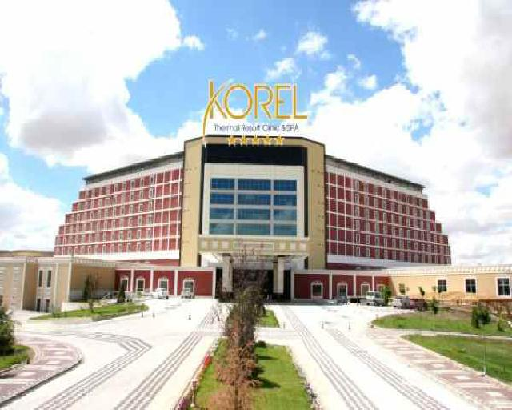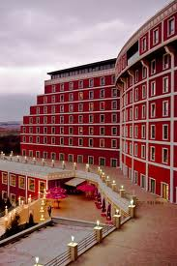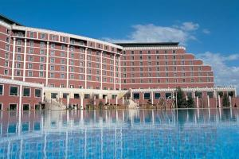
Cladding | Cladding in entrance , Precast
Facade Material | Coating+ Decorative Plaster + Paint
Facade Color | Combination of Brick color and white color
Facade Texture | No deviations are available on the facade, a smooth form was used. Console was used in on the pent house, connection of window frames with fringe was provided by buttresses and the mass was emptied in specific intervals, thus an emphasis was enabled.
Facade Elements | Windows are made of aluminum joint and surrounded by window frames. The fringe of the entrance door is considerable charming. Columned passages were used. Horizontal and vertical window frames were used on windows and on the facade. No balcony was used .
Facade Architectural Fiction | A linear order was enabled by the combination of windows and window frames. Masses are getting decreased towards upper floors, hierarchic fiction was provided accordingly, and the facade order was released from monotony “V” type facade form is available .
Facade Design Criteria | Balance |  | Symmetry | Harmonization | Proportion | Repeat
 | + |  | + | + | + | +

Figure 1. Hotel Korel (Source:Authors)

Name of the Hotel |  | HOTEL İKBAL
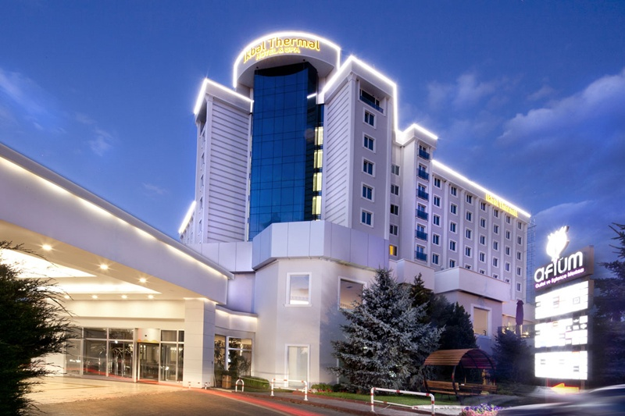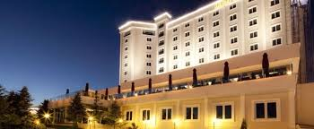
Cladding | Cladding, Glass cladding and precast facade
Facade Material | Aluminum composite panel, Window frames ,
Facade Color | White and grey tones
Facade Texture | Cove and flange were used in masses, different facade claddings were used, glass cladding was used on the entrance and transparency was provided, and the facade was released from monotony.
Facade Elements | Window joinery is PVC and surrounded by window frames. Entrance was raised and emphasized, and glass cladding system was used, surrounded by precast covering. No balcony was used on the facade
Facade Architectural Fiction | Different masses were used, thus facade movement was provided. Entrance was identified and hierarchic order was designed.“V” type plan scheme was designed, the facade order is in the same form as well .
Facade Design Criteria | Balance |  | Symmetry | Harmonization | Proportion | Repeat
 | + |  | + | + | + | +
Figure 2. Hotel İkbal (Source:Authors)

Name of the Hotel |  | HOTEL ORUÇOĞLU
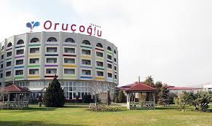
Cladding | No cladding
Facade Material | Coating +Plaster+ Paint
Facade Color | Tones of different colors on grey surface
Facade Texture | Balconies of bed floors are recessed and create an empty- full perception on the facade. Balconies on the top floor of the bed floors were completed with arches and a n integrity was provided vertically
Facade Elements | Diversity was enabled on the facade by using various tones of colors. Window joints are PVC, embedded balcony is available in front of each window .
Facade Architectural Fiction | A circular form was designed on the facades of bed floors and an harmonization was enabled to this circular form by arched balcony passages, this mass created a hierarchic perception on the hotel’s facade.
Facade Design Criteria | Balance |  | Symmetry | Harmonization | Proportion | Repeat
 |  |  |  | + |  | +
Figure 3. Hotel Orucoglu (Source:Authors)

Name of the Hotel |  | HOTEL ANEMON
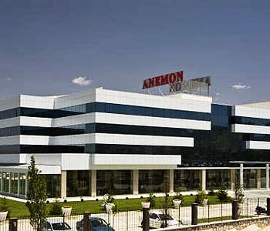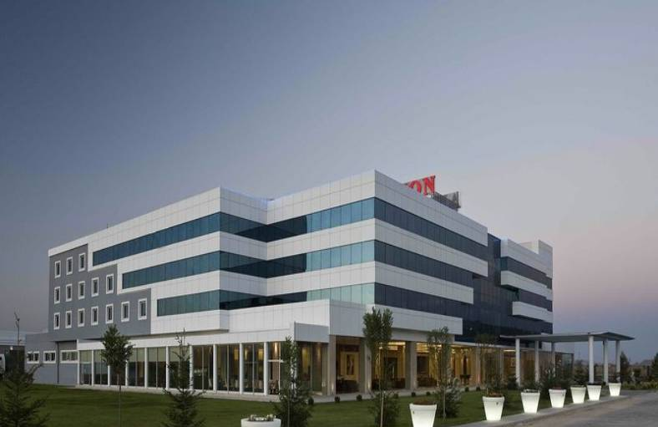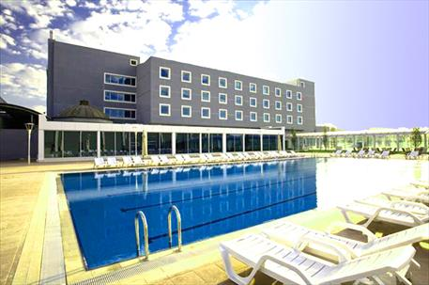
Cladding | Cladding
Facade Material | Aluminum composite panel
Facade Color | Grey tones
Facade Texture | Deviations were made on the facade, thus mass differences were provided. Windows were designed in a linear order and interpreted by different geometrical figures, the monotony perception of the facade was tried to be released accordingly.
Facade Elements | On the facade; along with cladding, square and rectangular formed windows were also used, Window joineries are made of PVC and surrounded by window frames. Columns were used on the surface for enabling the mass to be releases of monotony, and asymmetry was provided by coves and flanges on the cladding, no balcony is available .
Facade Architectural Fiction | Deviations were enables on a mass with rectangular form, spaces were created therein and different textures were used, thus an asymmetric architectural fiction was provided in an order.
Facade Design Criteria | Balance |  | Symmetry | Harmonization | Proportion | Repeat
 | + |  | + | + | + | +
Figure 4. Hotel Anemon (Source:Authors)

Name of the Hotel |  | HOTEL GÜRAL
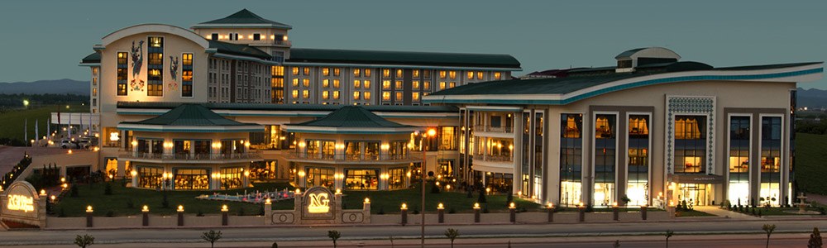
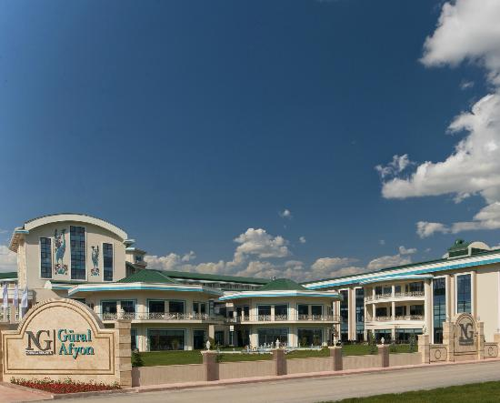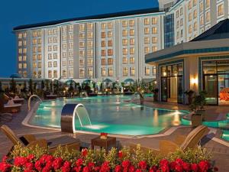

Cladding | Cladding
Facade Material | Silicone cladding , precast
Facade Color | Grey and green tones
Facade Texture | Ceramic panels with motives of bird were used on the facade, thus different textures were created. Masses with different forms and different roofing were designed and diversity was provided on the hotel’s façade accordingly .
Facade Elements | Windows with different forms and large window frames were used. Roof forms were also emphasized on the mass. Balconies were used in specific masses. Windows are with aluminum joineries and surrounded by ceramic ornaments.
Facade Architectural Fiction | Seljuk architecture was attributed by cupola style octagon forms and figures used on the facade. A mixture architectural design is available, with different mass compositions. Specific masses were emphasized, thus hierarchy was enabled. Ceramic panes with motives of bird inthe entrance were designed by referring to ceramic decorations which are seen intensively in Seljuk architecture.
Facade Design Criteria | Balance |  | Symmetry | Harmonization | Proportion | Repeat
 | + |  | + | + | + | +
Figure 5. Hotel Gural (Source:Authors)

Conclusion
The results derived from the survey are given below :
The materials used for the exterior facades of the hotels are preferred to be luxury items and to be mixed materials instead of unique material. Besides, hotel facades are preferred to be cladding type instead of being covered by stone or marble materials.
Various colors are preferred to be used for the hotels’ exterior facade architecture. Colorless and a plane hotel facade is not preferred
The proportion of positive replies received is considerable higher against the question in the survey on the effect of the hotel’ s exterior facade architecture over the charm and prestige of the hotel. Participants preferred a more modern facade concept instead of an excessive decorated sophisticated facade type. Consideration of creating an architectural design by using Seljuk and Ottoman architectural elements which are preferred in recent periods among the hotel concepts have been perceived considerable positive by the participants .
Participants preferred the door and window joineries to be made of wood within the hotels’ facade architecture and the rate of participants preferring PVC joineries is low. Participants preferred the usage of arched door, window and balcony on facades, thus they choose a traditional architecture. Besides, they preferred a panoramic facade where lobby is able to be seen from outside, thus a transparent facade perception was adopted.
Due to the holistic analysis of subjective evaluations received from the participants of the questionnaire based on an objective evaluation ;

For Hotel Korel ;
The unique color used in Hotel Korel’s facade paint was supported with white window frames and diversity of colors was increased, and it is possible to assert that, with this mixed but plane order a positive impression shall be available. Besides, window frames used in facade windows and fringes decreased the appearance of an ordinary facade impact and created a luxury material perception as in the questionnaire results and formed a more charming and rich facade emphasize.
Window frames and columns used in Hotel Korel’s facade added positive values. Creation of a modern style which is away from decoration by plane touching on the facade takes among the positive values according to the results of the questionnaire.
Repetition principle used in the emphasize of the hotel’s facade was applied over the windows which are considered by the participants as an identity factor. Mass deviations on Hotel Korel’s facade and identification of the entrance with a large fringe and its transparency due to cladding support the assertion that the facade should be charming and the entrance should take place in the front side of the hotel and should be charming.
Facade of the Hotel Korel carries the design principles which consist of harmonization, symmetry, balance, proportion and repetition. Within this context, it may be stated that; a positive impression could be enabled over the users due to hotel facade perception.
Non existence of balconies on the facade and inclusion of repeated window members may lead to a more monotone facade perception.

For Hotel İkbal;
The facade of Hotel İkbal which is based on a single color and a plane design may be interpreted negative in terms of the result of the survey. However, this monotony was released as coating and precast material was used for paving material as well as the window frames, and an awareness was added into the facade. This may be evaluated as a positive conclusion in terms of the results of the survey.
Inclusion of luxury material into the paving material and the charm created thereof may be evaluated as a positive perception. Emphasize of the hotel’s entrance with a hierarchic order, usage of glass cladding facade and transparency create a positive impression in terms of the results of the survey.
Harmonization, symmetry, proportion and repletion principles used in the design of the facade of the hotel provided contribution to the positive facade perception.

For Hotel Oruçoğlu ;
As no cladding material was used on the facade of the hotel and a single color was used for painting; a modern style cold not achieved, thus a negative impact was formed.
PVC joineries used on the windows of the facade may be said to have created a negative perception. It is possible to assert that hotel‘s facade is not charming.
Circulars and edged forms used on the facade created diversities and this can be evaluated as a positive perception according to the results of the survey. Existence of balcony, their coloring and closure of the top of the balconies by arches provided a positive effect according to the results of the questionnaire.
Only the harmonization and repetition principles were used in facade design.

For Hotel Anemon ;
As the facade of the hotel is based on curtain wall, this is evaluated positive in the results of the survey. As combinations were made with different geometric formal approaches on the facade besides curtain wall and as the facade order was released from monotony; these are the factors of positive impressions according to the results of the survey.
Aluminum material- colored hotel facade may be evaluated negative according to the results of the survey. However luxury materials used created a modern and charming perception.
Identification of hotel entrance, usage of columns on the floor and emptiness made on the masses provided dynamism on the facade which enabled a positive impression.
Harmonization, symmetry, balance, repetition and proportion principles were used totally in hotel design, and smmetry and balance impact could be created in the mass due to an asymmetric approach.

For Hotel Güral ;
Color tones used on the hotel facade and the harmonization of the colors may be evaluated positive according to the results of the survey. Ceramic panels with motives of birds applied on the external walls of the entrance and their attribution to Seljuk tiles, making reference to Seljuk architecture with octagon, large fringed masses are evaluated positively according to the results of the survey.
Charming windows were created by silicon covered facade application and a transparent facade perception arose accordingly. A linear order not involving repetitions was designed on the façade and monotony was released accordingly. Within this framework, the result of the survey matched with the data obtained.
Emphasize of hotel entrance, provision of hierarchy in hotel order and creation of awareness thereof may be evaluated positively according to the results of the survey.
Harmonization, balance, symmetry, repetition and proportion principles were all applied in hotel design.
Hotel’s facade creates a rarely charming perception and gives a prestigious building image. This approach verifies the assertion; “exterior facade increases the prestige of the hotel” which is obtained from the survey.
In the facade to be designed, in case principles such as repetition, symmetry, balance and order shall be used, they should be preferred to be used over the identity factors of the façade elements( window, window frame, fringe) However, the principle of “symmetry” when is not directed towards monotony or complexity, gain positive values. Color principles are perceived positive when harmonized with façade texture and when appropriate tones are selected. Within this context, a complex façade concept and colorful tones should not be preferred on facade designs Colors to be applied on the hotel’s façade should be selected in such a manner that they should emphasize the architectural features of the structure in aspecific order as well as to comply with the natural properties of the city where it is located, its architectural features and with the colors used. For making decision about which color order should be applied on the structure‘s surface, materials used on the surface should also play roles. The color; in order to strengthen the architecture of the structure and to introduce an identity into the environment which it is located, is required to be used in a specific order. In façade designs, instead of monotonous, orderly façades, those which are definite in terms of its dimension, shape and color, which is harmonized with the environment, defining generally historical elements with appropriate cladding should be preferred. As a result of the evaluations arose from stylistic data or from data obtained from surveys; it is seen that, façade design should not be considered as an independent work but as a holistic one. As the hotels are prestigious buildings of a city, hotels’ exterior façade architecture should be designed in combination with material, cladding, color and texture principles. One of the most important challenges in architecture is the constructions which are not able to be comprehended and communicated. This creates an identity problem in architecture and leaves a negative impression for city user. Within this context, the way required to be followed is that; necessary importance should attached to the concept of design, and the urban users and facades should be considered within the scope of a dialectic relation .

References
Alp, A., (1993).(Evaluation of Relations Between Space Arrangement and behavior in terms of the users spaces in Theatre buildings , Msc. Thesis, Y.T.Ü. Science Institute İstanbul.

Aydınlı, S., (1992). Visual Analysis in Architecture İ.T.Ü., the Faculty Of Architecture workshop printing, İstanbul.

Aydınlı, S., (1986). Spatial Perceptual Evaluation Based on Model Value, PhD Thesis, İ.T.Ü. Science Institute İstanbul.

Cimcoz, N., Texture and Facade materials in architectural Formatting, Başkaya, A.-D.I.

Çakırkaya. M., E., (1994). A Research of Design Development in istanbul 5 Star Luxury City Hotels), Master Thesis, İ.T.Ü. Science Institute İstanbul, 1-6, 87-115

Ertürk, S., (1984), An Experimental Study of Spatial Perception Architecture, PhD Thesis, Karadeniz Technical University, Science Institute,Trabzon.

Eryıldız, (eds.), Theory and Practice: Surface in Architecture Formatting, Ankara Turkey Chamber Of Architects, Engineers Union TMMOB Chamber Of Architects Ankara Branch, 2001: 373
Gürpınar, Ç., 2000. Investigation of users Psychological Effects on space fiction with examples, Master Thesis, Y.T.Ü. Science Institute İstanbul.

Hasol, D., (1990), Encyclopedic Dictionary of Architecture Yem Pres, İstanbul.
Jones, L.A., Lederman, S.J, (2006). Hand Function, Oxford University Press, New York.

Küller, R., (1979), A Semantic Test for Use in Cross-Cultural Studies, Man-Environment Systems, V.9, N.4-5, July and September, p. 253. Marmara University ,Fine Art Institute, Master Of Arts In Interior Design, İstanbul ,2006
Onat, E., (1991), Architecture Form and Geometry, yem Publications, İstanbul.

Önder, D. E., (1995). A method for evaluating spatial stepped in city hotels , PhD Thesis, Y.T.Ü. Science Institute İstanbul.

Özdemir, Başkaya A. (2005) Lean A Signaling String, Gazi University Journal of the Faculty of Engineering and Architecture, Vol. 16, Num. 1-2, 2001: 63-75, http://www.mmf.gazi.edu.tr/journal/index.html

Özdemir, T., (2005). Color Concept and Effects of Design Residential Interiors, PhD Thesis, Mimar Sinan University, Fine Art Institute, Master Of Arts In Interior Design, İstanbul.

Rasmussen, S. E., (1980), Experienced Architecture, İstanbul Technical University, Faculty Of Architecture Pres.

Şenyiğit Ö. and Altan İ. (2011). A Semantic Approach to Evaluate the Expression Tool with Facade: Investigation of the Constitutional Facades Meşrutiyet Street in Istanbul, Megaron; 6(3): 139-150.

Ustaömeroğlu A.A., (2001), The Formation Of The Surface And Visual Effects, Başkaya, A-D.I. Eryıldız, (eds.) Theory and Practice: Architectural Surfaces in Formatting, Turkey Chamber Of Architects, Engineers Union TMMOB Chamber Of Architects Ankara Branch, 2001: 89-99.

Wright, F.L., (1953). The Future of Architecture, New York: Horizon Pres, 1953.

Yolcu ,E, (2006), On City Hotels, Environment, Location, Design Principles, Master's Thesis,

